Q.1. Explain Client Server Architecture along with the diagram.

🡪 define:-A client send the request by using a

Web Browser, and the server responds based on the request received from the client.

Diagram:-

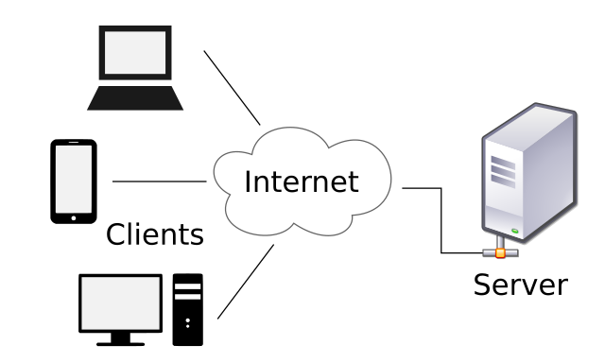

the client is a computer or device, also called a Host, that actually uses the service or accepts the information.

 The server is the providing the services to client devices and etc,

The client server architecture work on request bases in this process firstly client by using device on used a web browser send a request then request are received by server after receiving request server provide the services to on client devices.